Boiling observations

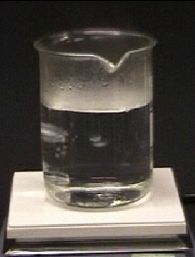
1. Water has a boiling point of 100 °C.
This water is being heated.

What temperature does the water start to boil?
A Around 90 °C
B Around 98 °C
C 100 °C
D Over 100 °C

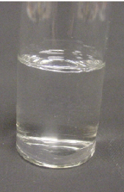
2. This pure substance has a boiling point of 56°C.
The substance is going to be heated.

What temperature does the substance start to boil?
A Around 50 °C
B Around 54 °C
C 56 °C
D 58 °C

Chemistry > Big idea CSU: Substances and properties > Topic CSU1: Substances and mixtures > Key concept CSU1.1: Substance
Diagnostic question
Boiling observations

Overview
Learning focus: | A chemical substance has a characteristic melting and boiling point and can exist in different states.
Observable learning outcome: | Match observations of boiling to the temperature at which they take place.
Question type: | Simple multiple choice
Key words: | liquid, gas, state, boiling point, temperature

What does the research say?
Johnson and Papageorgiou (2010) used questions to explore students’ understanding of macroscopic observations of melting in relation to melting point. Students with a sound understanding understood that melting point was the divide between the solid and liquid states and that a substance would show no signs of melting below the melting point (or of solidifying above this temperature whilst cooling).
However, some students considered melting point to be the start or end of a narrow zone over which melting or freezing (solidification) occurred.
Similar misunderstandings may be held by students in relation to boiling point.
Ways to use this question
Students should complete the question individually. This could be a pencil and paper exercise, or you could use an electronic ‘voting system’ or mini white boards and the PowerPoint presentation.
The answers to the question will show you whether students understood the concept sufficiently well to apply it correctly.
If there is a range of answers, you may choose to respond through structured class discussion. Ask one student to explain why they gave the answer they did; ask another student to explain why they agree with them; ask another to explain why they disagree, and so on. This sort of discussion gives students the opportunity to explore their thinking and for you to really understand their learning needs.
Expected answers
- C 2. C

How to respond - what next?
Students selecting A or B in either question may hold the idea that there is a lead in to boiling and that boiling begins as the temperature approaches the boiling point (rather than at the boiling point). Students are less likely to select D and any reason for doing so would be interesting to explore.
A good response to finding a misunderstanding, could be to teach the idea to the class and then give the students an activity in which they can practise using the concept so that they can consolidate their understanding. Question 2 could be reserved for this purpose. Responses often work best when the activities involve paired or small group discussions, which encourage social construction of new ideas through dialogue.
Acknowledgments
Developed by Helen Harden (UYSEG), from a York Science question devised by Andrew Hunt.
The questions were selected from a collection of ASK questions devised for research by Philip Johnson.
Images: Philip Johnson.
References
Johnson, P. and Papageorgiou, G. (2010). Rethinking the Introduction of Particle Theory: A Substance-based framework. Journal of Research in Science Teaching. 42(2) 130-150
Johnson, P. (2012). Introducing particle theory. In Taber, K. (ed.) ASE Science Practice: Teaching Secondary Chemistry. New edition ed. London: Hodder Education.

